Book

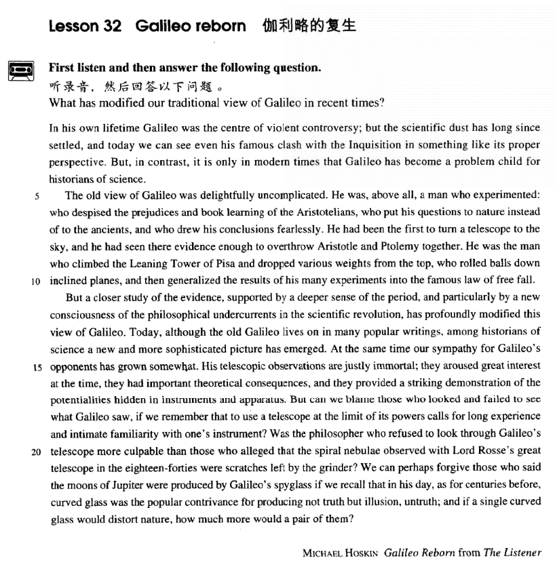

课文

In his own lifetime Galileo was the centre of violent controversy, but the scientific dust has long since settled, and today we can see even his famous clash with the Inquisition in something like its proper perspective.

伽利略在世时是激烈论战的中心。但是，自他逝世以来，那场科学上的纷争早已平息了下来，甚至他和宗教法庭的著名冲突，我们今天也能正确如实地看待。

But, in contrast, it is only in modern times that Galileo has become a problem child for historians of science.

但是相比之下，对于科学史家来说，伽利略只是在现代才变成了一个新的难题。

The old view of Galileo was delightfully uncomplicated.

令人高兴的是，过去对伽利略的看法并不复杂。

He was, above all, a man who experimented:

他首先是个实验工作者，

who despised the prejudice and book learning of the Aristotelians,

他蔑视亚里士多德学派的偏见和空洞的书本知识。

who put his questions to nature instead of to the ancients, and who drew his conclusions fearlessly.

他向自然界而不是向古人提出问题，并大胆地得出结论。

He had been the first to turn a telescope to the sky, and he had seen there evidence enough to overthrow Aristotle and Ptolemy together.

他是第一个把望远镜对准天空的人，观察到的论据足以把亚里士多德和托勒密一起推翻。

He was the man who climbed the Leaning Tower of Pisa and dropped various weights from the top,

他就是那个曾经爬上比萨斜塔，从塔顶向下抛掷积各种重物的人；

who rolled balls down inclined planes, and then generalized the results of his many experiments into the famous law of free fall.

他是那个使地球体沿斜面向下滚动，然后将多次实验结果概括成著名的自由落体定律的人。

But a closer study of the evidence, supported by a deeper sense of the period, and particularly by a new consciousness of the philosophical undercurrents in the scientific revolution, has profoundly modified this view of Galileo.

但是，对那个时代的深化了解，尤其是以科学家革命中哲学潜流的新意识为依据，进一步仔细研究，就会极大地改变对伽利略的看法。

Today, although the old Galileo lives on in many popular writings, among historians of science a new and more sophisticated picture has emerged.

今天，虽然已故的伽利略继续活在许多通俗读物中，但在科学史家中间，一个新的更加复杂的伽利略形象出现了。

At the same time our sympathy for Galileo's opponents has grown somewhat.

与此同时，我们对伽利略的反对派的同情也有所增加。

His telescopic observations are justly immortal;

伽利略用望远镜所作的观察确实是不朽的，

they aroused great interest at the time, they had important theoretical consequences, and they provided a striking demonstration of the potentialities hidden in instruments and apparatus.

这些观察当时引起人们极大的兴趣，具有重要的理论意义，并充分显示出了仪表和仪器的潜在力量。

But can we blame those who looked and failed to see what Galileo saw, if we remember that to use a telescope at the limit of its powers calls for long experience and intimate familiarity with one's instrument?

但是，如果我们想到，便用一架倍数有限的望远镜需要长期的经验和对自己仪器的熟悉程度，那么我们怎么能去责备观察了天空但没有看到伽利略所看到的东西的那些人呢？

Was the philosopher who refused to look through Galileo's telescope more culpable than those who alleged that the spiral nebulae observed with Lord Rosse's great telescope in the 1840s were scratches left by the grinder?

某位哲学家曾拒绝使用伽利略的望远镜去观察天空；到了19世纪40年代，有人硬把罗斯勋爵高倍望远镜观测到的螺旋状星云说成是磨镜工留下的磨痕。难道反对伽利略的哲学家比诋毁罗斯勋爵造谣者应受到更大的谴责吗？

We can perhaps forgive those who said the moons of Jupiter were produced by Galileo's spyglass if we recall that in his day, as for centuries before, curved glass was the popular contrivance for producing not truth but illusion, untruth;

如果我们回想一下伽利略之前几个世纪期间，曲面镜一直是一种用于产生幻影而不是产生真象的把戏装置，那么我们就会原谅那些当时把伽利略观察到的木星卫生说成是伽利略用他的小望远镜变出来的人们，

and if a single curved glass would distort nature, how much more would a pair of them?

何况一片曲面镜就可歪曲自然，那么伽利略的两片曲面镜对自然的歪曲又该多大呢？

词汇讲解

Lesson 32 Galileo reborn

controversy ['kɒntrəvɜ:si]

n. 争论，论战

controversy n. a serious argument about something that involves many people and continues for a long time 很多人参与的持久而激烈的论战Euthanasia continues to be an issue of much controversy.

Reports in today’s newspapers have added fuel to the controversy.

The movie has sparked / provoked / stirred a controversy over homosexuality.

controversial

a controversial issue / topic

He is a highly controversial figure in the art world. debate

International Varsity Debate dispute

The children’ dispute ended in a fight. be beyond dispute

China’s claims of sovereignty over the Diaoyu Islands are beyond dispute.

discord

Money is the biggest cause of discord in marriage. be in conflict with …

Union leaders are still in conflict with management. clash

a clash of swords

violent clashes between police and demonstrators

personality / culture clash collision

The play represents the collision of three generations. dust [dʌst]

n. 尘土；骚乱，混乱

Ashes to ashes and dust to dust.

For dust thou art, and unto dust thou shalt return. gather / collect dust

My guitar has just been gathering dust since I injured my hand.

It will take some time for the political dust to settle in that country. The scientific dust has long since settled.

After hearing your whole history with Mike, it doesn't take a genius to figure out what the problem is. What is it? You. You don't want to be happy. You're a drama junkie. When there is no drama, you create it.

You sleep with your ex-husband, you cheat on a coma victim and now you're hiking up a mountain after a guy who has no idea you're coming.

Who knows? Maybe this guy will take you back. But once the dust settles, you'll kick up some more because you don't know how to Just Be Happy. perspective

[pə'spektɪv]

n. 透视法；视角，角度，看法

perspective on …

The book deals with a woman’s perspective *on* revolution. from a historical / global / financial / Marxist perspective

The problem needs to be looked at from a historical perspective. angle / standpoint

Try looking at the problem from a different angle.

I think from a political standpoint it was a particularly bad idea. familiarity [fə7mɪli'ærəti]

n. 熟悉，通晓，精通

Ellen’s familiarity with music is astonishing. Familiarity breeds contempt.

— Aesop

sb. be familiar with sth. sth. be familiar to sb.

Many readers are familiar with the name Harry Potter. The name Harry Potter is familiar to many readers. acquaintance

My acquaintance with Spanish literature is rather limited.

I’m afraid I have only a passing acquaintance with Baroque music. be acquainted with sb. / sth.

I’m not acquainted with the lady.

She is well acquainted with classical literature. culpable ['kʌlpəbl]

adj. 应受谴责的，应受处罚的

culpable negligence be culpable for …

We are partly culpable for the state of events. hold sb. culpable

He was held culpable for what had happened. culpability

After the accident, the company refused to accept culpability. be responsible for …

He is responsible for the accident. hold sb. responsible

He held me responsible whenever anything went wrong. responsibility

Terrorists have claimed responsibility for the bomb attack. Galileo (1564-1642)

Italian physicist and astronomer, who initiated the scientific revolution that flowered in the work of the English physicist Sir Isaac Newton.

His main contributions were, in astronomy, the use of the telescope in observation and the discovery of sunspots, lunar mountains and valleys, the four largest satellites of Jupiter.

He discovered that the planets moved around the sun, which confirmed Copernicus’ theory and overthrew Ptolemaic system of astronomy.

In physics, he discovered the laws of falling bodies. In the history of culture, Galileo stands as a symbol of the battle against authority.

He died in 1642. At the same year, the great physicist Isaac Newton was born.

As it happened, he died on January 8, 1642, and 300 years later, that is January 8, 1942, another great theoretical physicist Stephen Hawking was born.

*In his own lifetime* Galileo was the centre of violent controversy; but the scientific dust has long since settled, and today we can see even his famous clash *with the Inquisition in something like its proper perspective*. in / during one’s lifetime

He achieved a lot in his short lifetime.

During her lifetime she had witnessed two world wars.

All this will not be finished in the first one hundred days. Nor will it be

finished in the first one thousand days; nor in the life of this Administration; nor even perhaps in our lifetime on this planet. But let us begin.

sth. of a lifetime / one’s life

the chance / experience / vacation of a lifetime / one’s life

—Did you enjoy your vacation in Paris?

—It was the vacation of a lifetime / my life! Galileo was the centre of violent controversy.

➔ Galileo was a highly controversial figure. long since … 早已……，早就……

Spring flowers are long since gone. Summer's bloom hangs limp on every

terrace.

— Louise Seymour Jones

The Immortal has long since gone with his yellow crane, Only the Yellow Crane Tower can now be seen.

No one has been sure if the bird would ever return, Over thousands of years the white clouds remain. I’ve long since forgotten any Latin I ever learned. I've long since forgiven what she did.

The people who built the temple have long since vanished. clash n. conflict; collision

the Inquisition / the Holy Office

a Roman Catholic organization in the past whose aim was to find and punish people who had unacceptable beliefs

something like …

They say creating a work of art is something like giving birth. The house looks something like a medieval fortress.

Something like 50,000 homes are without power.

One authority on spiders made a census of the spiders in grass field in the south of England, and he estimated that there were more than 2,250,000 in one acre; that is something like 6,000,000 spiders of different kinds on a football pitch.

something between … and …

The look on Max’s face was something between puzzlement and anger. His income is something between $30,000 and $35,000 a year.

Galileo maintained that the earth revolved around the sun, disputing the belief held by the Roman Catholic church that the earth was the center of the universe.

He refused to obey orders from Rome to cease discussions of his theories and was sentenced to life imprisonment. It was not until 1984 that a papal commission acknowledged that the church was wrong.

But, in contrast, it is only in modern times that Galileo has become a

problem child for historians of science. in / by contrast

in / by comparison

An old watch, by contrast, becomes so worn and unreliable that it eventually is not worth mending.

It is not until modern times that … a problem child

a child whose behavior is bad

a child whose behavior causes problems for other people the view of Galileo

Galileo’s view

my view of the situation delightfully

delightedly

I delightedly accepted the gift.

He was, above all, a man who experimented: who despised the prejudices

and book learning of the Aristotelians, who put his questions to nature

instead of to the ancients, and who drew his conclusions fearlessly.

一个人能力有大小，但只要有这点精神，就是一个高尚的人，一个纯粹的人，一个有道德的人，一个脱离了低级趣味的人，一个有益于人民的人。

prejudice

Pride and Prejudice prejudice *against* women bias *against* …

bias *in favor of / toward(s)* … partiality *to / toward(s)* … be prejudiced *against* …

be biased *against* …

be biased *in favor of / toward(s)* … be partial *to / toward(s)* … Aristotle

Greek philosopher and scientist

He shares with Plato and Socrates the distinction of being the most famous of ancient philosophers. He is also the tutor of Alexander the

Great.

He is the author of works on logic, metaphysics, ethics, natural science, politics, and poetics. And he profoundly influenced western thought.

Aristotle proposed a finite, spherical universe, with the earth as its center. He also held that heavier bodies fall faster than lighter ones.

put questions to …

He picked up the gun from *behind* the counter.

The weather has been fine except *in* the north.

He studies in the evening instead of *during* the day.

More and more people live in towns and cities instead of *in* villages. Giordano Bruno

A man’s ability may be great or small, but if he has this spirit, he is a man who is noble-minded, who is pure, who is of moral integrity, who is above vulgar interests, and who is of value to the people.

He had been the first *to turn a telescope to the sky*, and he had seen there evidence enough to overthrow Aristotle and Ptolemy together.

Ptolemy

Ancient Greek astronomer, mathematician, and geographer

He based his astronomy on the belief that all heavenly bodies revolve around the earth.

His astronomical theories and explanations dominated scientific thought until the 16th century when Copernicus, a Polish astronomer, advanced the theory the earth and other planets revolve around the sun, disrupting the Ptolemaic astronomy.

He was the man who climbed the Leaning Tower of Pisa and dropped

various weights from the top, who rolled balls down inclined planes, and

then *generalized* the results of his many experiments *into* the famous law

of free fall.

Leaning Tower of Pisa

Started in 1173, the Leaning Tower of Pisa in Italy is an example of Romanesque architecture. It is actually the bell tower of the cathedral of Pisa.

Legend has it that Galileo once carried out experiments at the leaning tower which showed that the velocity of moving bodies of the same composition, but of different weights, do not attain the proportion of their weights as Aristotle decreed, but move with the same velocity.

inclined plane generalize sth. into sth.

But a closer study of the evidence, supported *by a deeper sense of the*

*period*, and particularly *by a new consciousness of the philosophical*

*undercurrents in the scientific revolution*, has profoundly modified this view of Galileo.

be supported by … be based on …

…, based on a deeper sense of the period. sense n. understanding / consciousness

profoundly adv. deeply; extremely

She was profoundly influenced by her mother. modify

The mediator attempted to get both sides to modify their position.

Today, although the old Galileo lives on in many popular writings, *among*

*historians of science* a new and more sophisticated picture has emerged. Where do the knives live in your kitchen?

Can you form a picture of what I described to you?

Most of us have formed an unrealistic picture of life on a desert island. opponent n. adversary; antagonist

His telescopic observations are justly immortal; they aroused great interest at the time, they had important theoretical consequences, and they provided a striking demonstration of the potentialities hidden in instruments and apparatus.

a just reward / punishment

ecological consequences

It is true that China is still a developing country, but she is full of potential / potentialities.

laboratory apparatus a piece of apparatus

But can we blame those who looked and failed to see what Galileo saw, *if we remember that to use a telescope at the limit of its powers calls for*

*long experience and intimate familiarity with one's instrument*? a 200-power microscope

a 32-power telescope call for

This sort of work calls for a high level of concentration. The quality is variable, so careful selection is called for.

In this era of rapid social and technological change leading to increasing

life complexity and psychological displacement, unforeseen and kaleidoscopic challenges facing persons in most professions and academic fields call for a balance *in which there are both imagination and knowledge*.

need / require / demand

What are the qualities that are needed for the job?

A lot of patience is required to look after a disabled child. This is a complex task and demands a high level of skill. it takes sth. to do sth.

It takes stamina to be a long-distance runner.

It takes a lot of patience to look after a disabled child. Anyone can be passionate, but it takes real lovers to be silly.

— Rose Franken

Any intelligent fool can make things bigger, more complex, and more violent. It takes a touch of genius and a lot of courage to move in the opposite direction.

— Albert Einstein

entail sth. / doing

entail sb. doing

The job entails a lot of hard work.

The journey entails changing trains twice.

I’ll never accept parole because that entails me accepting guilt. necessitate sth.

A prolonged drought necessitated the introduction of water rationing. But we cannot blame those who …

O, wind, if winter comes, can spring be far behind?

‘Ode to the West Wind’

P. B. Shelley

We often speak of tramps with contempt and put them in the same class as beggars, but how many of us can honestly say that we have not felt a little envious of their simple way of life and their freedom from care?

Could any spectacle, for instance, be more grimly whimsical than that of gunners using science to shatter men’s bodies while, close at hand, surgeons use it to restore them?

They tell us, sir, that we are weak; unable to cope with so formidable an adversary. But when shall we be stronger? Will it be the next week, or the next year? Will it be when we are totally disarmed, and when a British

guard shall be stationed in every house? Shall we gather strength by irresolution and inaction? Shall we acquire the means of effectual resistance by lying supinely on our backs and hugging the delusive phantom of hope, until our enemies shall have bound us hand and foot?

—Patrick Henry, *‘Give Me Liberty Or Give Me Death’*

They tell us, sir, that we are weak; unable to cope with so formidable an adversary. But when shall we be stronger? Will it be the next week, or the next year? Will it be when we are totally disarmed, and when a British guard shall be stationed in every house?

Shall we gather strength by irresolution and inaction? Shall we acquire the means of effectual resistance by lying supinely on our backs and hugging the delusive phantom of hope, until our enemies shall have bound us hand and foot?

*‘Give Me Liberty Or Give Me Death’*

— Patrick Henry, March 23, 1775

They tell us, sir, that we are weak; unable to cope with so formidable an adversary. But when shall we be stronger? Will it be the next week, or the next year? Will it be when we are totally disarmed, and when a British guard shall be stationed in every house? Shall we gather strength by irresolution and inaction? Shall we acquire the means of effectual resistance by lying supinely on our backs and hugging the delusive

phantom of hope, until our enemies shall have bound us hand and foot?

—Patrick Henry, *‘Give Me Liberty Or Give Me Death’*

Was the philosopher who refused to look through Galileo's telescope more culpable than those who alleged *that the spiral nebulae observed*

*with Lord Rosse's great telescope in the eighteen-forties were scratches left by the grinder*?

allege

He alleged that they had hired an assassin to dispose of him.

We can perhaps forgive those who said the moons of Jupiter were

produced by Galileo's spyglass *if we recall that in his day, as for*

*centuries before, curved glass was the popular contrivance for producing not truth but illusion, untruth*; and if a single curved glass would distort nature, how much more would a pair of them?

…, as curved glass was the popular contrivance for producing not truth but illusion, untruth for centuries before, curved glass was the popular contrivance for producing not truth but illusion, untruth; ……

On the occasions when they have pushed to shore an unconscious human being they have much more likely done it out of curiosity or for sport, as in riding the bow waves of a ship.

On the occasions when they have pushed to shore an unconscious human being they have much more likely done it out of curiosity or for sport, as

they have done it out of curiosity or for sport in riding the bow waves of a ship.

It is almost always due to some very special circumstances that traces of land animals survive, as by falling into inaccessible caves, or into an ice crevasse, like the Siberian mammoths, when the whole animal is sometimes preserved, as in a refrigerator.

It is almost always due to some very special circumstances that traces of land animals survive, as traces of land animals survive by falling into inaccessible caves, or into an ice crevasse, …

… like the Siberian mammoths, when the whole animal is sometimes preserved, as the whole animal is preserved in a refrigerator.

curve curved curved glass convex lens concave lens